Olympic Performance Prediction Using Machine Learning

Problem Id: 26
STATEMENT: Design and develop an end-to-end machine learning system to analyze and predict Olympic Games performance using numerical sports data. The project involves selecting a suitable Olympic dataset containing features such as athlete participation counts, medal totals, event statistics, and country-wise performance across multiple years. Data preprocessing techniques including data cleaning, normalization, and transformation are applied to ensure consistency and reliability of the data. Exploratory Data Analysis is performed to analyze medal distributions, participation trends, and performance variations across countries and time periods using statistical summaries and trend analysis. Visualization techniques such as bar charts, line plots, and heatmaps are used to understand long-term performance patterns and relationships between variables. Correlation analysis is conducted to identify key factors influencing medal outcomes. Based on insights obtained from EDA, relevant features are selected to improve model performance (PCA, Forward Selection, Backward Selection). Machine learning models are then developed to predict medal counts using regression techniques or to classify countries into performance categories such as high, medium, or low performance. The trained models are evaluated using appropriate performance metrics (F1 score) to assess their predictive effectiveness, demonstrating a complete machine learning pipeline from raw sports data to evaluated predictive models.

Student Details:
- Name : Vansh Kadiyan
Class Roll Number: 21
University Roll Number : 2028512
Section and Group: G(G1)

- Name : Hrimandeep Singh
Class Roll Number: 06
University Roll Number : 2028429
Section and Group: G(G1)

- Name : Aarav Fangalia
Class Roll Number: 26
University Roll Number : 2028604
Section and Group: G(G1)

INDEX

- Problem Description 4
- Architecture 5
- Models used 6
- Evaluation metrics used 7
- Preliminary Results and Visualizations 8-10
- References 11

- Problem Description:

The Olympic Medal Prediction System is a machine learning-based application developed to analyse historical Olympic data and predict whether a country will win a medal. The dataset contains multiple features such as number of athletes, participation rate, GDP index, previous medal counts, and other performance indicators.

In real-world scenarios, such a system can help sports authorities and analysts:-
- Identify high-performing countries
- Understand factors influencing medal wins
- Improve training and participation strategies
- Allocate resources efficiently

The system uses classification algorithms to automate prediction and reduce manual analysis effort. By applying preprocessing, feature engineering, and model optimization techniques, the system achieves high prediction accuracy.

- Architecture:

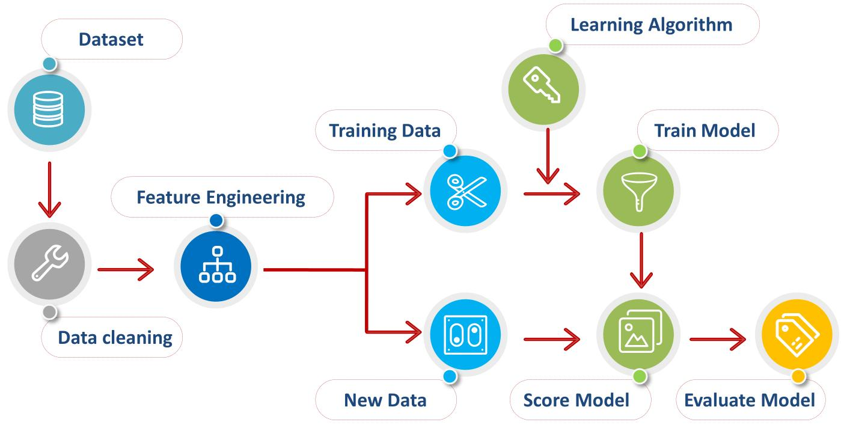

- Models Used (Applied/ Planned) :

- Logistic Regression
A linear model used for binary classification. It predicts probability using sigmoid function.

- Random Forest
An ensemble model combining multiple decision trees to improve accuracy and reduce overfitting.

- Support Vector Machine
Finds optimal hyperplane to separate classes.

- K-Nearest Neighbors
Classifies based on similarity between data points.

- Evaluation metrics used:

- Accuracy
Measures overall correctness of the model.

- Precision
Measures correctness of positive predictions.

- Recall
Measures ability to find actual positives.

- F1 Score
Balances precision and recall.

- Confusion Matrix
Shows correct and incorrect predictions.

5. Preliminary Results and Visualizations:

Visualizations Used
- Count plots
- Correlation heatmap

Observations
- GDP Index and Participation Rate strongly affect medal outcome
- Countries with higher athlete participation have better chances
- Random Forest gives highest accuracy

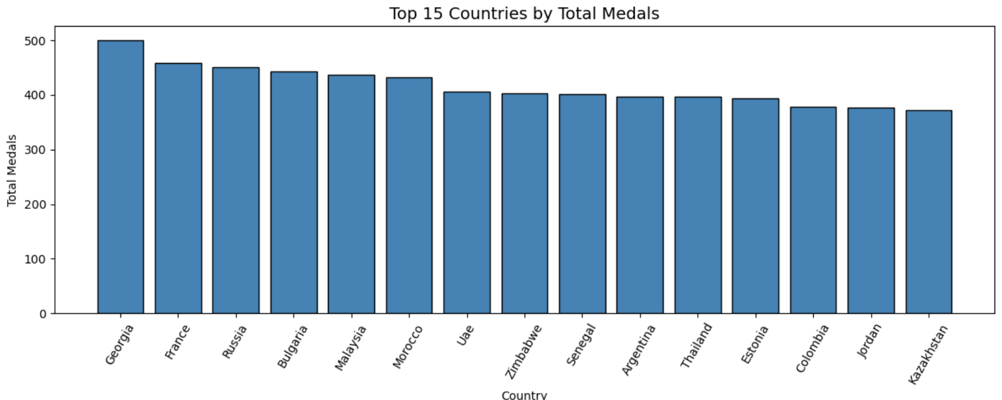

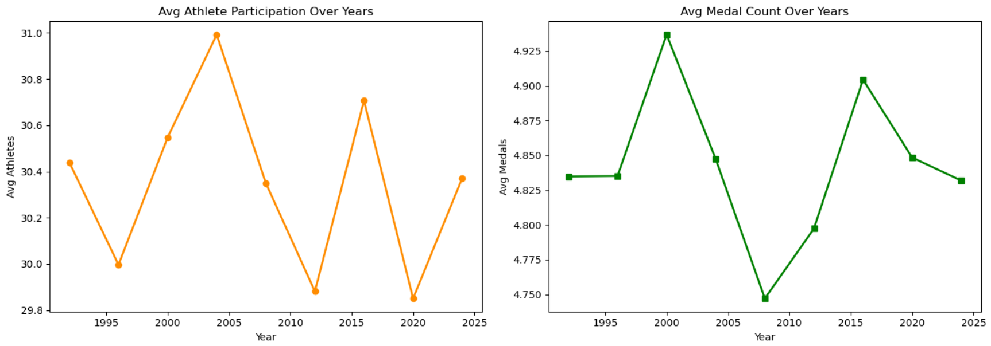
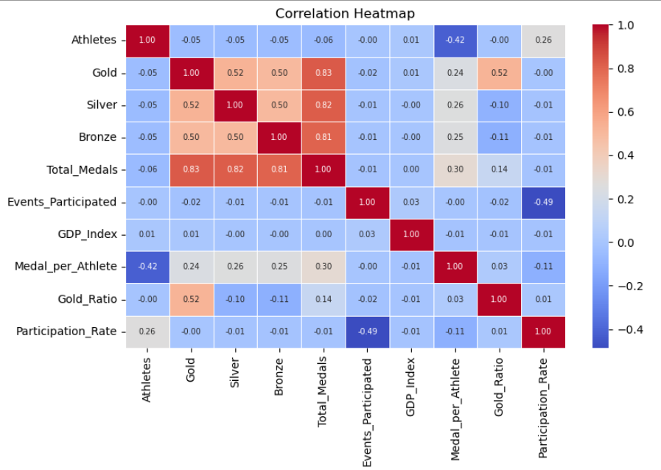

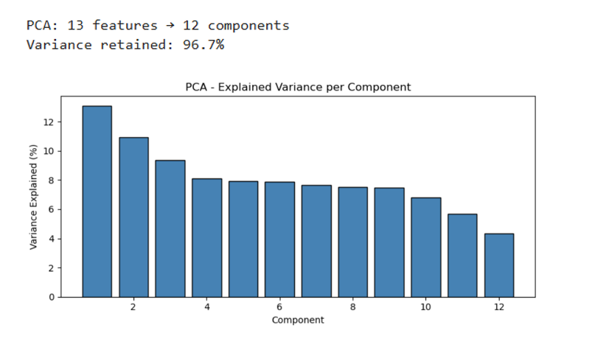

6. References:

- Platform Required:
1. Jupyter Notebook
Jupyter Notebook is used for writing and executing Python code in an interactive environment. It helps in step-by-step implementation, data analysis, and visualization.
2. Python (IDLE / VS Code)
Python is the main programming language used for implementing the project. It provides simple syntax and supports libraries required for data analysis and visualization.

3. Operating System (Windows)
A Windows-based system is used to run Python programs and required tools smoothly.

- Books and Link Sources:
1. “Let Us Python” by Yashavant Kanetkar1
This book helped in understanding basic Python concepts like loops, functions, and data handling which were used in the project.
2. “Programming in Python” by Reema Thareja
Used for learning core programming concepts and practical implementation of Python programs.
3. Kaggle (https://www.kaggle.com)
Used for accessing real-world datasets such as Olympic data for analysis.
4. Matplotlib Documentation (https://matplotlib.org)
Used to understand plotting techniques for visualization like bar charts and line graphs.

